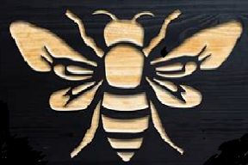

Hi Ward;

Here is a 6 inch wide by 5(ish) Bee logo for your car. It can be made into several styles:

Magnetic signs (for quick removal)

As a decal for permanent mounting

The yellow can be cut out as a silhouette (with the yellow car showing through)

The black can be cut out as a stencil